Bradley Nursery School

Privacy Notice

(How we use pupil information)

The categories of pupil information that we collect, hold and share include:
- Personal information (such as name, unique pupil number and address)
- Characteristics (such as ethnicity, language, nationality, country of birth and free school meal eligibility)
- Attendance information (such as sessions attended, number of absences and absence reasons)
- Assessment information
- Medical conditions
- Special Educational Needs and Disability Information
- Behaviour and exclusions
- Safeguarding and Child Protection

Why we collect and use this information
We use the pupil data:

- to support pupil learning
- to monitor and report on pupil progress
- to provide appropriate pastoral care
- to assess the quality of our services
- to comply with the law regarding data sharing
- to safeguard pupils

The lawful basis on which we use this information
On the 25th May 2018 the Data Protection Act 1998 will be replaced by the General Data Protection Regulation (GDPR). The condition for processing under the GDPR will be:
Article 6
- Processing shall be lawful only if and to the extent that at least one of the following applies:
(c) Processing is necessary for compliance with a legal obligation to which the controller is subject;
Article 9
- Processing of personal data revealing racial or ethnic origin, political opinions, religious or philosophical beliefs, or trade union membership, and the processing of genetic data, biometric data for the purpose of uniquely identifying a natural person, data concerning health or data concerning a natural person’s sex life or sexual orientation shall be prohibited.
- Paragraph 1 shall not apply if one of the following applies:
(j) Processing is necessary for archiving purposes in the public interest, scientific or historical research purposes or statistical purposes in accordance with Article 89(1) based on Union or Member State law which shall be proportionate to the aim pursued, respect the essence of the right to data protection and provide for suitable and specific measures to safeguard the fundamental rights and the interests of the data subject.
The Education (Information about Individual Pupils) (England) Regulations 2013 - Regulation 5 'Provision of information by non-maintained special schools and Academies to the Secretary of State' states 'Within fourteen days of receiving a request from the Secretary of State, the proprietor of a non-maintained special school or an Academy (shall provide to the Secretary of State such of the information referred to in Schedule 1 and (where the request stipulates) in respect of such categories of pupils, or former pupils, as is so requested.'
The Education Act 1996 - Section 537A – states that we provide individual pupil information as the relevant body such as the Department for Education.
Children's Act 1989 – Section 83 – places a duty on the Secretary of State or others to conduct research.
Collecting pupil information
Whilst the majority of pupil information you provide to us is mandatory, some of it is provided to us on a voluntary basis. In order to comply with the General Data Protection Regulation, we will inform you whether you are required to provide certain pupil information to us or if you have a choice in this.

Storing pupil data

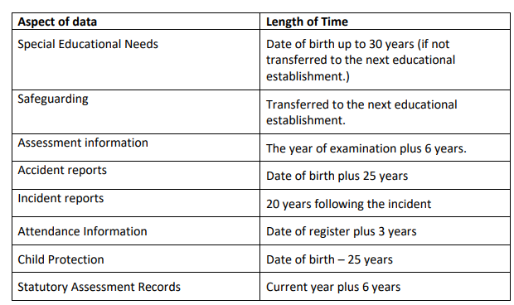

Who we share pupil information with
We routinely share pupil information with:

- schools that the pupil’s attend after leaving us
- our local authority
- the Department for Education (DfE)
- NHS/school nurse

Why we share pupil information
We do not share information about our pupils with anyone without consent unless the law and our policies allow us to do so.
We share pupils’ data with the Department for Education (DfE) on a statutory basis. This data sharing underpins school funding and educational attainment policy and monitoring.
We are required to share information about our pupils with our local authority (LA) and the Department for Education (DfE) under section 3 of The Education (Information About Individual Pupils) (England) Regulations 2013.

Data collection requirements:
To find out more about the data collection requirements placed on us by the Department for Education (for example; via the school census) go to https://www.gov.uk/education/data-collection-and-censuses-for-schools.

The National Pupil Database (NPD)
The NPD is owned and managed by the Department for Education and contains information about pupils in schools in England. It provides invaluable evidence on educational performance to inform independent research, as well as studies commissioned by the Department. It is held in electronic format for statistical purposes. This information is securely collected from a range of sources including schools, local authorities and awarding bodies.
We are required by law, to provide information about our pupils to the DfE as part of statutory data collections such as the school census and early years’ census. Some of this information is then stored in the NPD. The law that allows this is the Education (Information About Individual Pupils) (England) Regulations 2013.
To find out more about the NPD, go to https://www.gov.uk/government/publications/national-pupil-database-user-guide-and-supporting-information.
The department may share information about our pupils from the NPD with third parties who promote the education or well-being of children in England by:
- conducting research or analysis
- producing statistics
- providing information, advice or guidance
The Department has robust processes in place to ensure the confidentiality of our data is maintained and there are stringent controls in place regarding access and use of the data. Decisions on whether DfE releases data to third parties are subject to a strict approval process and based on a detailed assessment of:
- who is requesting the data
- the purpose for which it is required
- the level and sensitivity of data requested: and
- the arrangements in place to store and handle the data
To be granted access to pupil information, organisations must comply with strict terms and conditions covering the confidentiality and handling of the data, security arrangements and retention and use of the data.
For more information about the department’s data sharing process, please visit: https://www.gov.uk/data-protection-how-we-collect-and-share-research-data
For information about which organisations the department has provided pupil information, (and for which project), please visit the following website: https://www.gov.uk/government/publications/national-pupil-database-requests-received

To contact DfE: https://www.gov.uk/contact-dfe

Requesting access to your personal data
Under data protection legislation, parents and pupils have the right to request access to information about them that we hold. To make a request for your personal information, or be given access to your child’s educational record, contact Mrs Tracy Marlow - Headteacher or Mrs Victoria Heap - Data Protection Officer.

You also have the right to:
- object to processing of personal data that is likely to cause, or is causing, damage or distress
- prevent processing for the purpose of direct marketing
- object to decisions being taken by automated means
- in certain circumstances, have inaccurate personal data rectified, blocked, erased or destroyed; and
- claim compensation for damages caused by a breach of the Data Protection regulations
If you have a concern about the way we are collecting or using your personal data, we request that you raise your concern with us in the first instance. Alternatively, you can contact the Information Commissioner’s Office at https://ico.org.uk/concerns/

Contact
If you would like to discuss anything in this privacy notice, please contact:
Mrs Tracy Marlow - Headteacher
Mrs Victoria Heap - Data Protection Officer.

